|  |
| --- |
| **ability** |

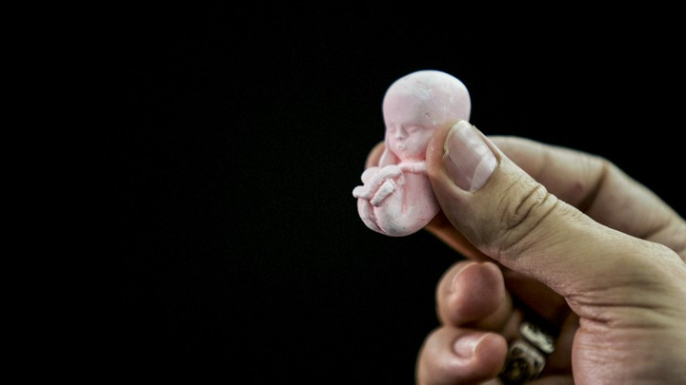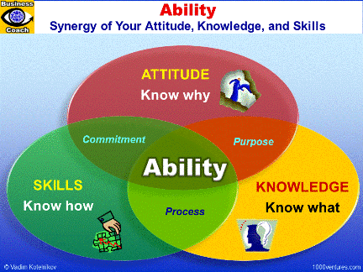He had no doubts about his team's ability to reach the World Cup finals.  
I admire his ability to listen.  
The company aims to select people of outstanding ability.  
She has the ability to make people feel relaxed.

|  |
| --- |
| **abortion: miscarriage** |

She decided to have/get an abortion.  
Abortion is restricted in some American states.

|  |
| --- |
| **about to…** |

***We use the modal expression be about to as an adjective in the modal expression be about to to refer to something that will happen very soon in the future:***

He was about to phone the police.

|  |
| --- |
| **absolutely** |

Are you absolutely sure?  
This cake is absolutely delicious.  
He has absolutely no experience of marketing.  
Jim knew absolutely nothing about the business when he joined the firm.  
The burglars took absolutely everything.

|  |
| --- |
| https://tr.newworldai.com/wp-content/uploads/2019/10/abuse.jpg  **abuse** |

Many children suffer from racial abuse at school.  
An independent committee will look into alleged human rights abuses.  
A self-monitoring tax system is clearly open to abuse (=able to be used wrongly).  
She is continually abusing her position/authority by getting other people to do things for her.  
I never expected that he would abuse the trust I placed in him.  
If you abuse your body now, you'll pay the price when you're older.  
Several of the children had been sexually/physically/emotionally abused.

|  |
| --- |
| **accelerate** |

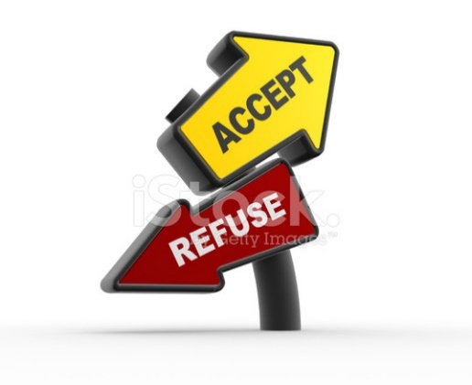There are fears that higher oil prices would accelerate inflation.  
Inflation is likely to accelerate this year, adding further upward pressure on interest rates.  
They use special chemicals to accelerate the growth of crop.

|  |
| --- |
| **accept  ≠  refuse** |

Do you accept credit cards?  
She was in Mumbai to accept an award for her latest novel.  
I offered her an apology, but she wouldn't accept it.  
I accept full responsibility for the failure of the plan.  
We've offered her the job, but I don't know whether she'll accept it.  
After a lot of careful thought, she decided to accept their offer.

|  |
| --- |
| **access** |

The only access to the village is by boat.  
The main access to (= entrance to) the building is at the side.  
The children's father was refused access to them at any time (= refused official permission to see them).  
The balcony is accessed by a spiral staircase from the bar.

|  |
| --- |
| **accident** |

She was injured in a car/road accident.  
Sinan died in a traffic accident.  
Hakan must have had an accident

|  |
| --- |
| **accomplish** |

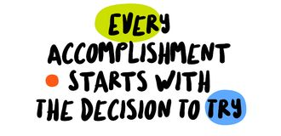The students accomplished the task in less than ten minutes.  
I feel as if I've accomplished nothing since I left my job.  
Mission accomplished.

|  |
| --- |
| **accomplishment** |

Cutting the budget was an impressive accomplishment.  
Playing the piano is one of her many accomplishments.  
That was the greatest accomplishment of my life.

|  |
| --- |
| **according to** |

According to Sarah they're not getting on very well at the moment.  
According to our records you owe us $130.  
According to my mother, you have to eat three meals a day every day.  
According to a company spokesman, the firm is expected to have sales of more than $3.5 billion this year.

|  |
| --- |
| **accumulate** |

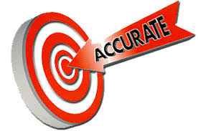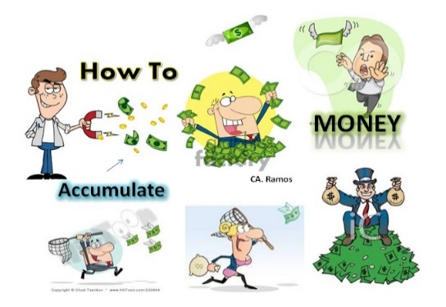During a successful business career, she accumulated a great amount of wealth.  
By the late 1950s, scientists had already accumulated enough evidence to show a clear link between smoking and cancer.

|  |
| --- |
| **accurate** |

***correct, exact, and without any mistakes:***  
The brochure tries to give a fair and accurate description of each hotel.  
The evidence she gave to the court was not strictly accurate (=not exactly accurate).  
Police believe Derek gave a reasonably accurate account of what happened.  
The witness tried to give an accurate description of what she had seen.

|  |
| --- |
| **accuse** |

"It wasn't my fault." "Don't worry, I'm not accusing you."  
He's been accused of robbery/murder.  
Are you accusing me of lying?  
The surgeon was accused of negligence.

|  |
| --- |
| **achieve: succeed** |

The government's training policy, he claimed, was achieving its objectives.  
She finally achieved her ambition to visit South America.

|  |
| --- |
| **achievement: success** |

You are very modest about your achievements, talents and abilities.  
Winning the award was a great achievement.

|  |
| --- |
| **acknowledge /eknalic/** |

***to admit or accept that something is true or that a situation exists***  
He acknowledges that when he’s tired he gets bad-tempered.  
Claire acknowledged that she was guilty.  
The government must acknowledge what is happening and do something about it.  
Both defendants refused to acknowledge (**accept**) the authority of the court.

|  |
| --- |
| **act** |

The new president’s first act should be to end the war.  
He’s been acting strangely ever since his mom died.  
Stop acting like a baby.  
He acted as if he'd never met me before.  
Engineers acted quickly to repair the damaged pipes.



***a law or formal decision made by a parliament or other group of people who make the laws for their country:***  
an Act of Parliament  
The state legislature passed an act banning the sale of automatic weapons.

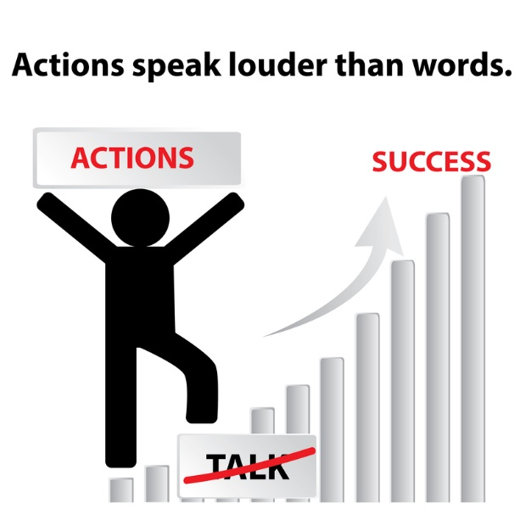

|  |
| --- |
| **action** |

Don't tell me how to do this; show me!  
**Actions speak louder than words.**

|  |
| --- |
| **active /ektif/** |

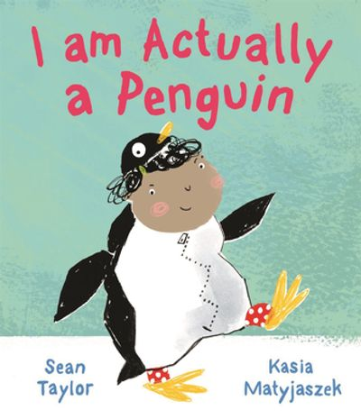It's good for old people to stay active if they can.  
I had an active social life when I was at college.  
She's very active in (= involved in) local politics.  
Both of his parents were very politically active.  
It is important to educate children before they become sexually active.  
He takes a more active role in the team nowadays.

|  |
| --- |
| **actually** |

***in fact or really:***

I didn't actually see her - I just heard her voice.  
So what actually happened?  
I didn't actually want any more dessert, but Julia forced it on me.  
We actually had a hard time moving the sofa.

|  |
| --- |
| **ad = advertisement** |

I often prefer the ads on TV to the actual programmes.  
He finds that job ads placed in prominent papers like the Financial Times serve him well.



|  |
| --- |
| **add** |

Do you want to add your name to the list?  
Add 7 and 5 to make 12.  
Is there anything you’d like to add, David?  
If you add (= calculate the total of) three and four you get seven.

|  |
| --- |
| **addicted** |

A lot of people nowadays have become addicted to the internet.  
By the age of 14, he was addicted to heroin.  
I'm addicted to (= I very often eat) chocolate.  
Fifty million Americans are addicted to nicotine.  
One in seven people is addicted to alcohol or drugs.

|  |
| --- |
| **admire** |

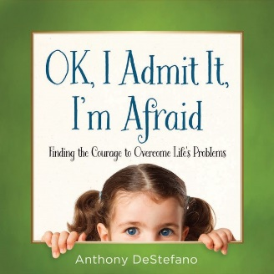I admired him for his determination.  
I really admire people who can work in such difficult conditions.

|  |
| --- |
| **admit: confess** |

He admitted his guilt/mistake.  
She admitted (that) she had made a mistake.  
She admitted making a mistake.  
At first, he denied stealing the money but he later admitted (to) it.

|  |
| --- |
| **adult** |

An adult under English law is someone over 18 years old.  
Adults pay an admission charge but children get in free.

|  |
| --- |
| **adultery** /edalderi/ zina |

***sex between a married man or woman and someone he or she is not married to:***

Many people in public life have committed adultery.

|  |
| --- |
| **adulthood** |

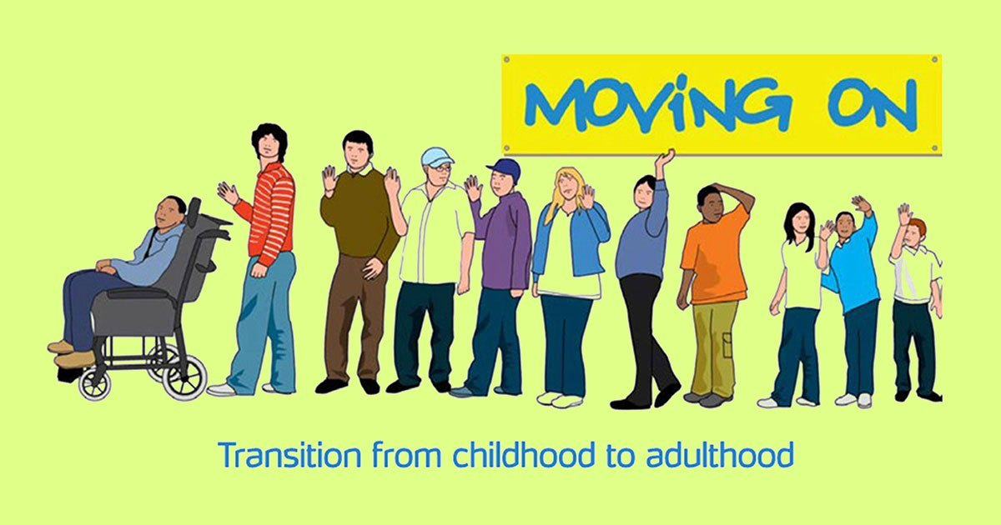People in Turkey legally reach adulthood at 18.

|  |
| --- |
| **advantage** |

For a goalkeeper, it's a great advantage to have big hands.  
His height and reach give him a big advantage over (= make him better than) other boxers.  
I thought I'd take advantage of the sports facilities while I'm here.  
I know she's offered to babysit, but I don't want her to think we're taking advantage of her.  
The advantage of the plan is its simplicity.  
You shouldn't be so trusting - people take advantage of you.

|  |
| --- |
| **advent** |

***the fact of an event happening, an invention being made, or a person arriving:***  
Life was transformed by the advent of the steam engine.  
Long before the advent of robots and personal computers, he invented a race of super-intelligent robots.  
Many more people died of infections before the advent of penicillin.

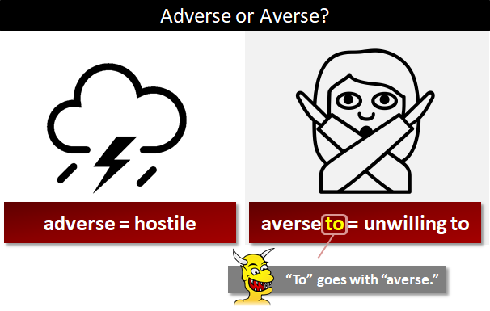***the period of four weeks before Christmas***

|  |
| --- |
| **adventure** |

She had some exciting adventures in Egypt.  
This book is a thrilling adventure story.  
As a young man, he went off to Africa, looking for adventure.  
Willis was a young man looking for adventure.  
He always used to tell us about his adventures at sea.

|  |
| --- |
| **adverse** |

They fear it could have an adverse effect on global financial markets.  
Climate change is likely to have adverse impacts on human health.  
A lot of companies have been adversely affected by the recession.  
You risk being judged adversely by some listeners whenever you give a presentation.

|  |
| --- |
| **advice** |

Steven gave me some good advice.  
I think I'll take your advice (= do what you suggest) and get the green dress.  
Can I give you a piece of advice?  
I need some advice on which computer to buy.

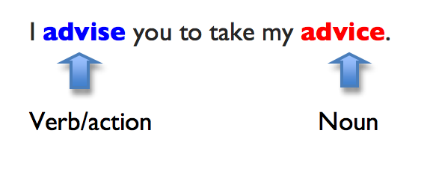

|  |
| --- |
| **advise** |

His doctor advised him against smoking.  
I'd strongly advise against making a sudden decision.  
They're advising that children be kept at home.  
I'd advise waiting until tomorrow.

|  |
| --- |
| **advocate** |

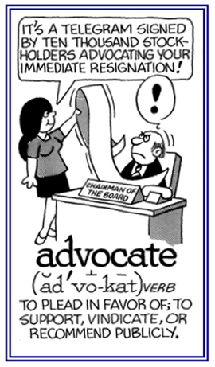***to publicly support or suggest an idea, development, or way of doing something:***  
He advocates the return of capital punishment.  
The author denied that his new book advocated violence.  
Some extremists are now openly advocating violence.

***a lawyer who defends someone in a law court***

There is not much difference between a lawyer and an advocate. Lawyer is a generic or basic term for all who practice or study law, it includes the advocates as well.

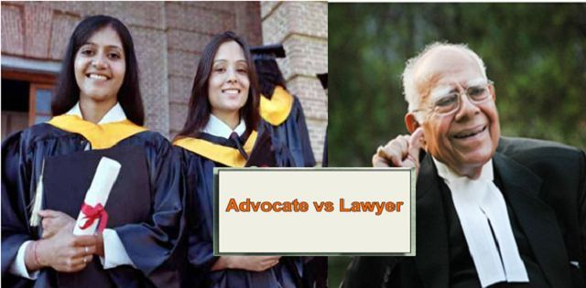

|  |
| --- |
| **affect** |

Both buildings were badly affected by the fire.  
The divorce affected every aspect of her life.  
It's a disease that affects mainly older people.  
If this project fails, it will affect **not only** our department, **but also** the whole organization.

**Not only** did he turn up late, he **also** forgot his books.

|  |
| --- |
| **affiliate** |

***to cause a group to become part of or form a close relationship with another, usually larger, group, or organization:***  
The school is affiliated with a national association of driving schools.  
The Society is not affiliated with any political party.

***an organization that is connected with or controlled by another, usually larger, organization:***  
Our college is an affiliate of the university.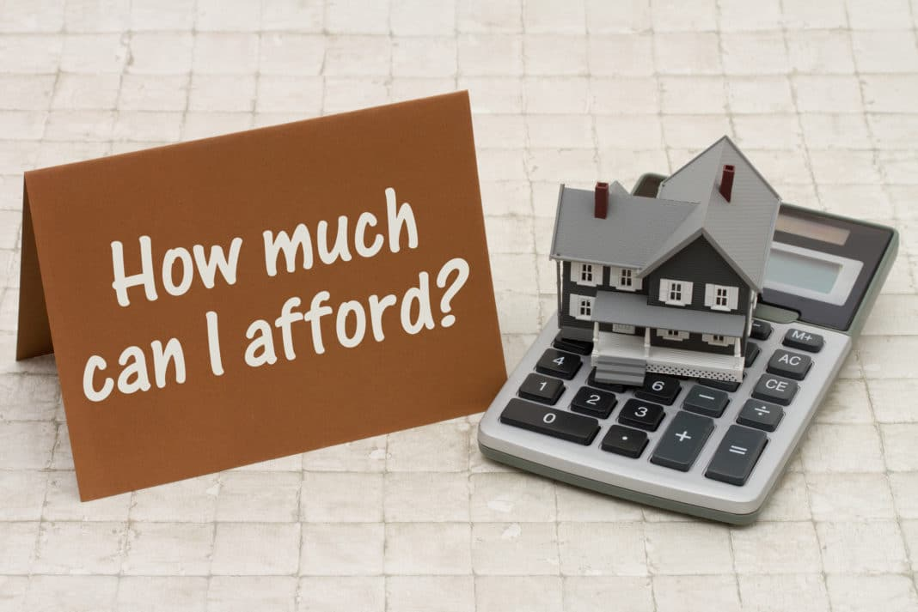

|  |
| --- |
| **afford** |

You could always hire a dress for the ball if you can't afford to buy one.  
I don't know how he can afford a new car on his salary.  
I can't afford to buy a house.



|  |
| --- |
| **affordable** |

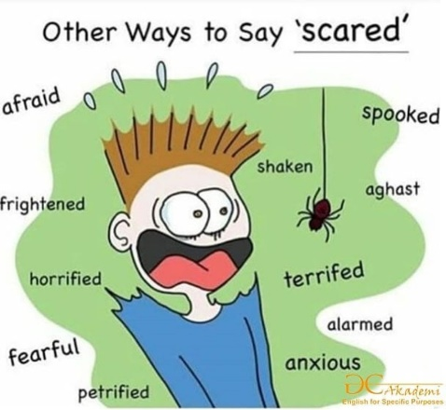This is a top-quality product at a very affordable price.  
Affordable housing isn’t enough – we also need job opportunities.  
They are meeting consumer demand for fashionable products at affordable prices.

|  |
| --- |
| **afraid : scared of** |

I'm **afraid** you've completely misunderstood the question.  
I've always been afraid of flying/heights/spiders.  
Don't be afraid to say what you think.  
Being afraid of the dark, she always slept with the light on.

|  |
| --- |
| **after** |

Let's go for a walk after breakfast.  
Some people believe in life after death.  
Her name came after mine on the list.  
There's a good film on the day after tomorrow.  
After (= because of) what she did to me, I'll never trust her again.  
I'll meet you down at the club after work.  
I went to the post office straight/immediately after I left you.

|  |
| --- |
| **after you** |

"Can I pour you some coffee?" "Oh no, **after you**."

|  |
| --- |
| **aftermath** |

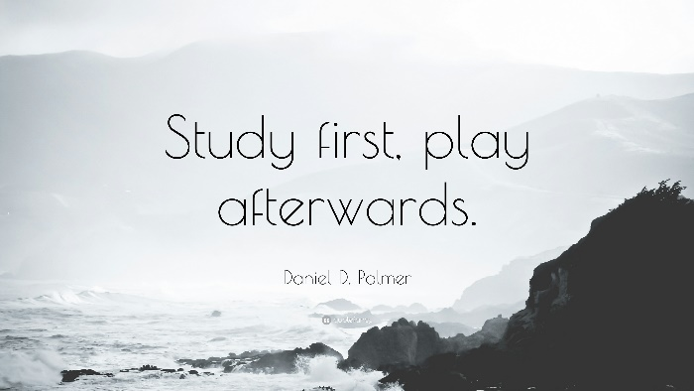We all worked together in the aftermath of the earthquake.  
Many more people died in the aftermath of the explosion.

|  |
| --- |
| **afterward = afterwards** |

The operation was rather painful, but I felt a lot better afterwards.  
We had tea, and afterwards we sat in the garden for a while.  
They separated, and soon/shortly afterwards Jane left the country.  
If you're a good boy at the doctor's I'll take you swimming afterwards.

|  |
| --- |
| **aggregate = total** |

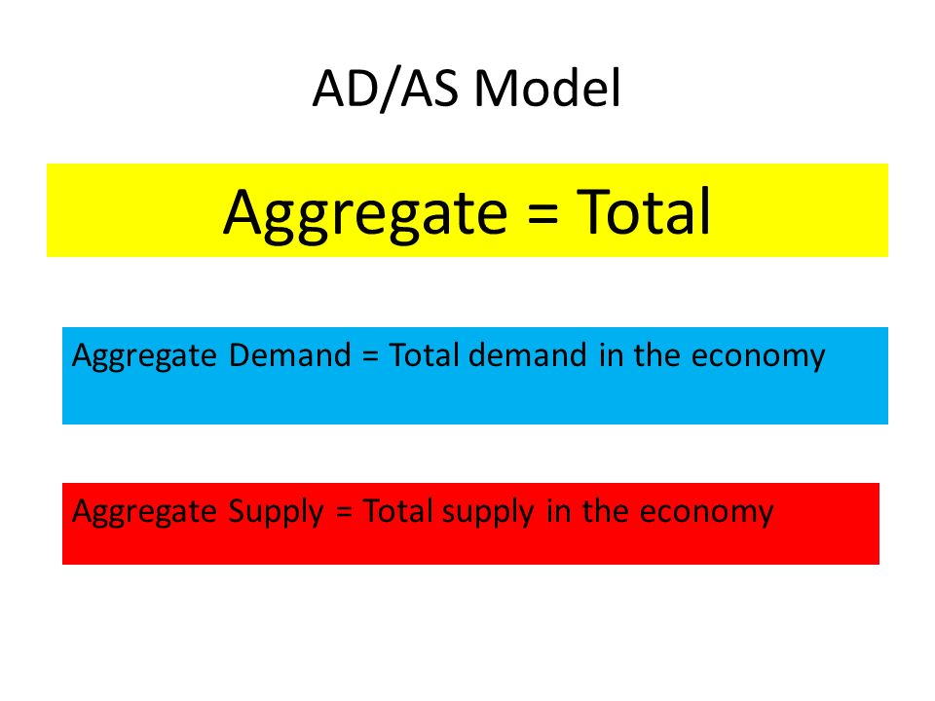***something formed by adding together several amounts or things:***  
They purchased an aggregate of 3,000 shares in the company.  
The seven companies have an aggregate turnover of £5.2 million.  
The smaller minorities got an aggregate of 1,327 votes.

***to bring different things together:***  
The company aggregates news and information from a number of sources on its website.  
Sheila's earnings from all sources aggregated $100,000.

|  |
| --- |
| **aggressive** |

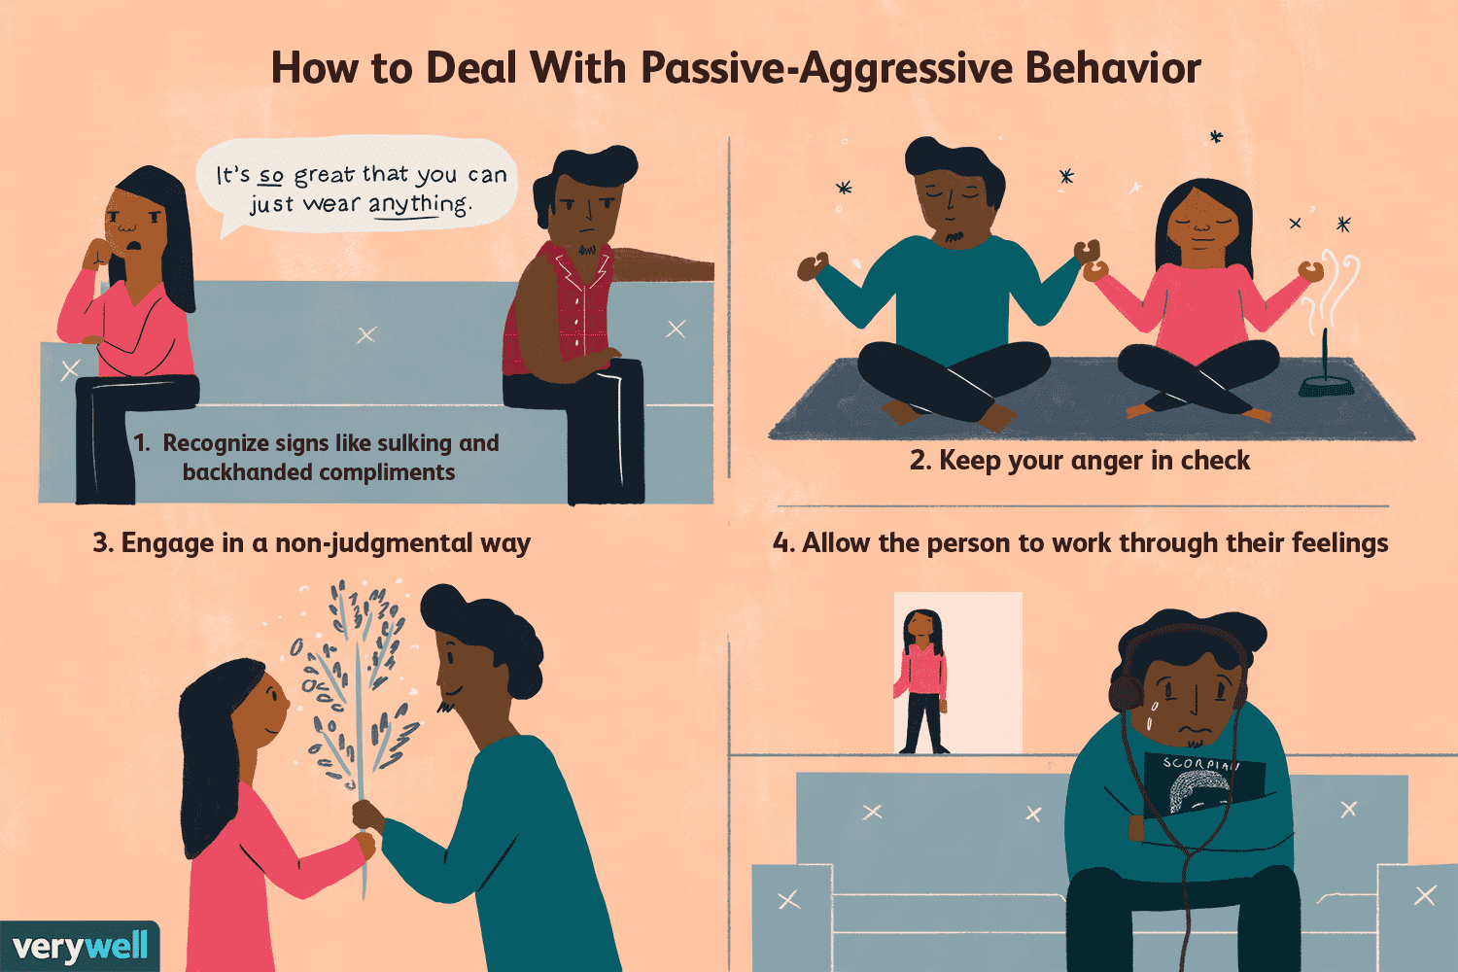***behaving in an angry and violent way towards another person:***  
The stereotype is that men tend to be more aggressive than women.  
If I criticize him, he gets aggressive and starts shouting.  
Teachers apparently expect a certain amount of aggressive behaviour from boys.  
The company is struggling to fight off aggressive competitors.

|  |
| --- |
| **ago** |

He left the house over an hour ago.  
The dinosaurs died out 65 million years ago.  
Long ago/A long time ago, there lived a girl called Cinderella.

|  |
| --- |
| **agonize /egınayz/** |

***to think about a difficult decision very carefully and with a lot of effort.***  
He agonized for several days before agreeing to move to Oklahoma.

***to spend a lot of time trying to make a decision:***  
She agonized for days over whether she should take the job.

|  |
| --- |
| **agony /egıni/** |

***very severe pain***

I was in agony.  
He groaned in agony.  
It was agony not knowing if she would live.  
He was lying on the floor in agony.

|  |
| --- |
| **agree** |

The bank has agreed to lend me €5000.  
I agree that he should be invited.  
I agree **with you** on this issue.

|  |
| --- |
| **agriculture : farming** |

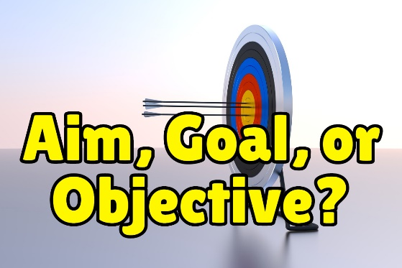Agriculture is still largely based on traditional methods in some countries.  
The area ***depends on*** agriculture for most of its income.

|  |
| --- |
| **aim : goal** |

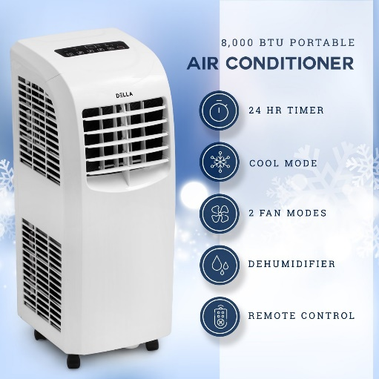My main **aim** in life is to be a good husband.  
Our short-term **aim** is to ***deal with*** our current financial difficulties.  
Our common **aim** is to see Turkey remaining in the European family and recognising the importance of democracy, human rights and the rule of law, even at this most challenging time.

|  |
| --- |
| **air conditioner** |

An air conditioner to maintain normal room temperature is advisable.  
In countries like India, Brazil and Indonesia, the market for air conditioners is expanding at double-digit rates.

|  |
| --- |
| **air conditioning: AC** |

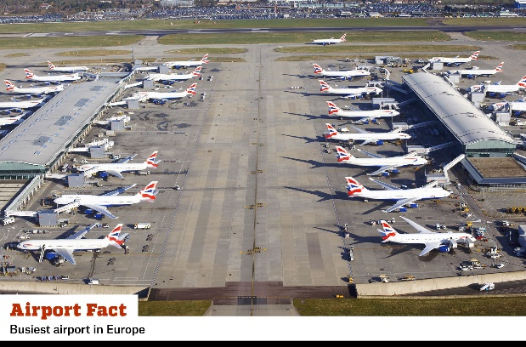How do you manage to work in this heat without air conditioning?  
There was no air conditioning, just a ceiling fan turning slowly.  
If you don't keep the windows closed, the air conditioning can't work properly.  
Since the invention of air conditioning, we have been able to control the weather inside, and that has had some some far-reaching and unexpected effects.

|  |
| --- |
| **aircraft : airplane: plane** |

Please remember to take all your personal possessions with you when you leave the aircraft.  
Attacks by enemy aircraft forced the tanks to retreat from the city.

|  |
| --- |
| **airport** |

Security checks have become really strict at the airport.  
It's about two kilometers from the airport to your hotel.  
We arrived at the airport just in time to catch the plane.

|  |
| --- |
| **akin to** |

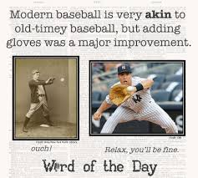***very similar to something***  
The flavor is akin to chicken.  
They speak a language akin to French.

|  |
| --- |
| **alcohol** |

We’re not allowed to serve alcohol to people under 18.  
I don't drink alcohol or smoke.  
Ted doesn't drink alcohol anymore.  
Most wines contain around twelve percent alcohol.  
I could smell the alcohol on his breath. 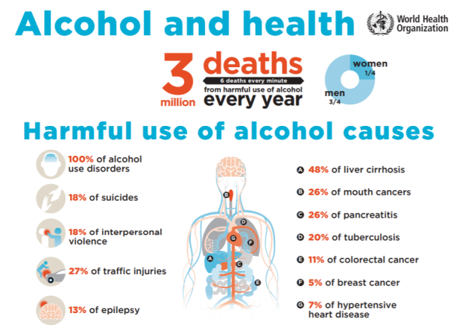

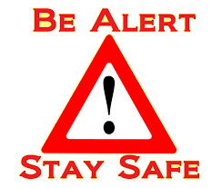

|  |
| --- |
| **alert** |

*quick to see, understand, and act in a particular situation:*  
I'm not feeling very alert today - not enough sleep last night!  
A couple of alert readers posted comments on the website pointing out the mistake.  
Parents should be alert to sudden changes in children's behaviour.

*to warn someone of a possibly dangerous situation:*  
An anonymous letter alerted police to the possibility of a terrorist attack at the airport.  
I alerted everyone I had contact with but had the choice to keep it private.

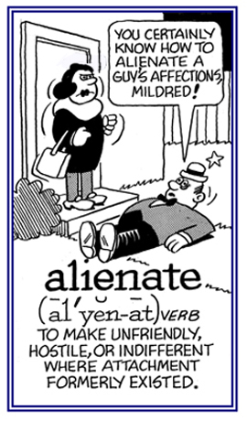

|  |
| --- |
| **alienate** |

***to do something that makes someone unfriendly or unwilling to support you***  
***to make it difficult for someone to belong to a particular group or to feel comfortable with a particular person***  
The latest tax proposals will alienate many voters.  
He felt that his experiences had alienated him from society.  
Gina had become alienated from her family.

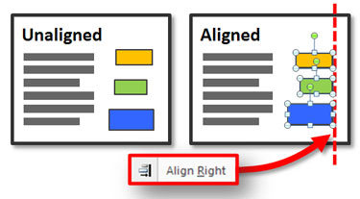

|  |
| --- |
| **align with** |

***uyumlu hale getirme***

This policy is closely aligned with the goals of the organization.  
The desks were neatly aligned in rows.  
You need to align the numbers properly in a column.  
Business leaders are aligned with (= agree with) the president on this issue.

|  |
| --- |
| **all in all** |

***used to show that you are considering every part of a situation; considering all the different parts of the situation together:***  
All in all, it had been one of the most miserable days of Henry’s life.  
All in all, I think you've done very well.

|  |
| --- |
|  |
|  |
|  |
| **all of a sudden** |

*very quickly: immediately*

It seemed to happen all of a sudden - I felt dizzy and I just collapsed.  
All of a sudden the lights went out.

|  |
| --- |
| **all right** |

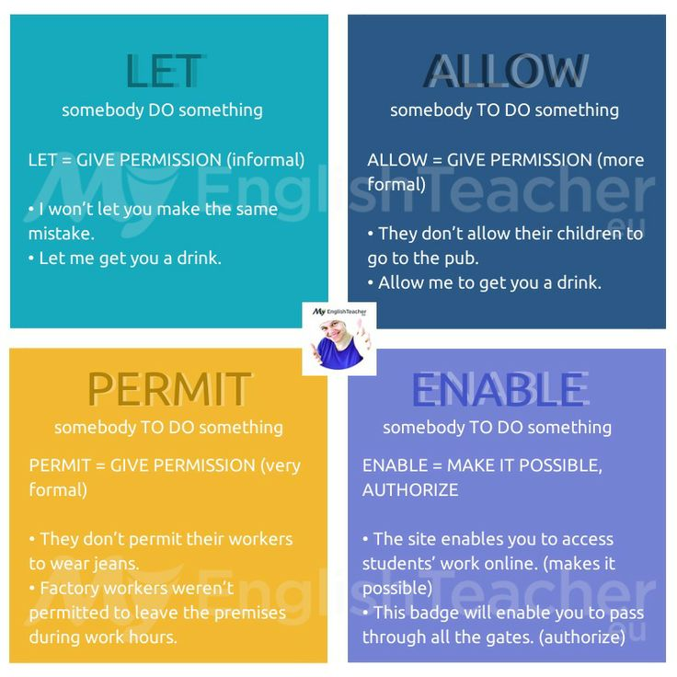That should be all right.  
That is all right..

|  |
| --- |
| **allow : permit : let** |

You're not allowed to talk during the exam.  
Smoking is not allowed in this restaurant.

|  |
| --- |
| **alone** |

She lives alone.  
You shouldn’t leave a child alone in the house.  
My wife and I like to spend time alone together away from the kids.



|  |
| --- |
| **aloud** |

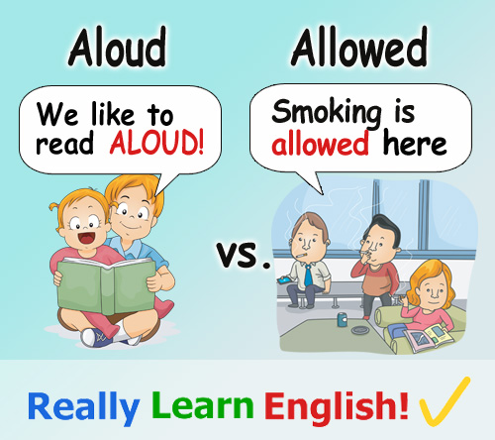He read her letter aloud to the rest of the family.  
People are starting to wonder aloud (= question publicly) whether the economic reforms have gone too far.  
It would be a useful exercise for you to say the speech aloud several times.  
Children love to have stories read aloud to them.  
"What did you say?" "Oh, nothing, I was just thinking aloud."  
The judge asked her to read the jury's verdict aloud.



|  |
| --- |
| **alter** |

***to change something, usually slightly, or to cause the characteristics of something to change:***  
We've had to alter some of our plans.  
You can alter the whole appearance of a room just by lighting it in a certain way.  
Nothing can alter the fact that the refugees are our responsibility.  
His mood suddenly altered and he seemed a little annoyed.

|  |
| --- |
| **alternatively** |

We could go to the Indian restaurant, or alternatively, we could try that new Italian place.  
You could catch the 18.30 train - alternatively, you could wait for the 19.50 fast train.  
It would be a six-month wait for the operation but, alternatively, you could pay for private treatment.

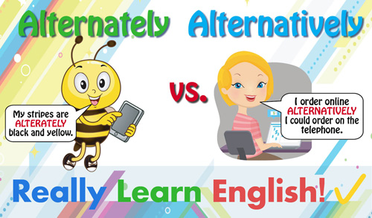

|  |
| --- |
| **altruism** |

***willingness to do things that bring advantages to others, even if it results in disadvantage for yourself:***  
She's not known for her altruism.  
Nobody believes those people are donating money to the president’s party purely out of altruism.  
Many choose to work in developing countries out of altruism.

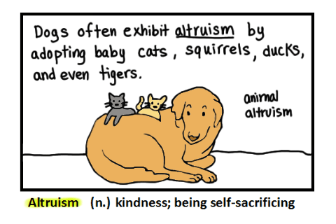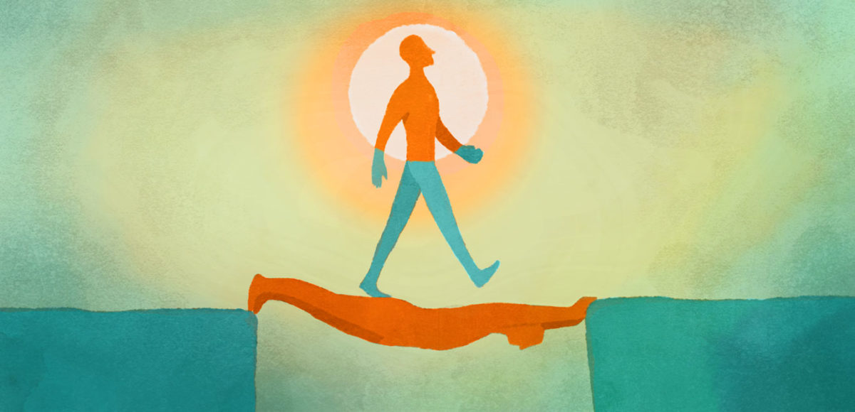

|  |
| --- |
| **always** |

She always spells my name wrong.  
My mum always comments on what I'm wearing.  
You're always complaining.  
You always try to do your best.

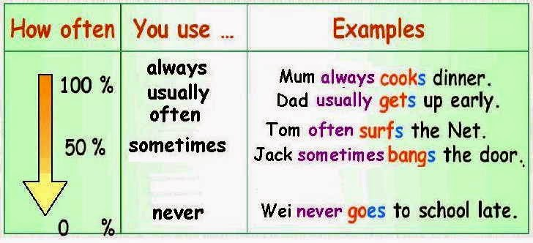

|  |
| --- |
| **amazing** |

It’s amazing how often you see drivers using mobile phones.  
This stain remover really works - it's amazing!  
The new theatre is going to cost an amazing (= very large) amount of money.  
It's amazing that no one else has applied for the job.

|  |
| --- |
| **amazingly** |

Amazingly, he was able to walk around without being recognized.  
Amazingly, the book took only six days to write.  
The food was amazingly good.

|  |
| --- |
| **amend** |

***to correct or make small changes to something that is written or spoken***  
The law was amended to include women.  
MPs were urged to amend the law to prevent another oil tanker disaster.  
In line 20, "men" should be amended (= changed) to "people".

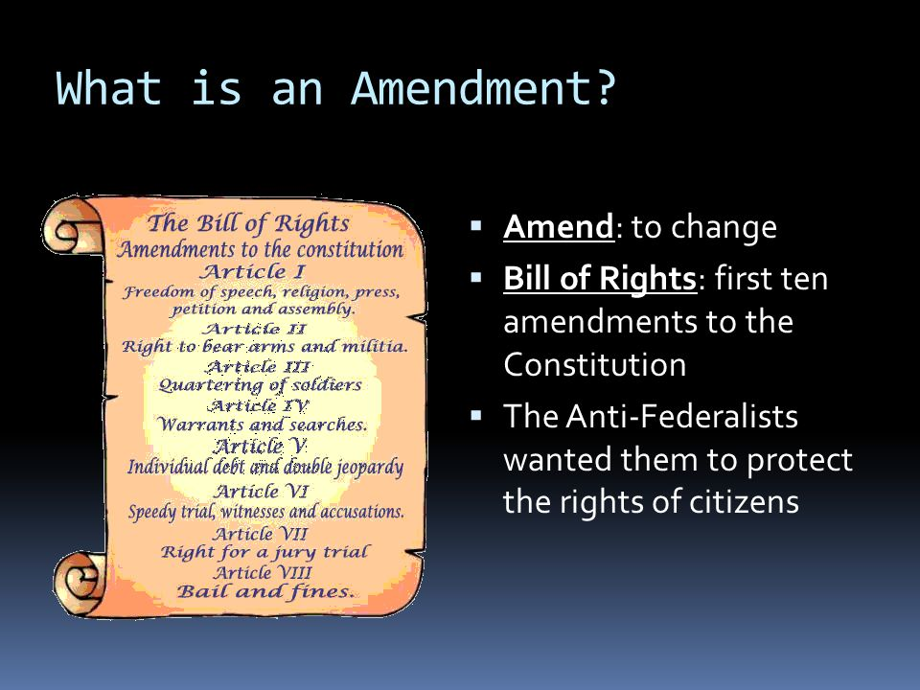

|  |
| --- |
| **amid: amidst** |

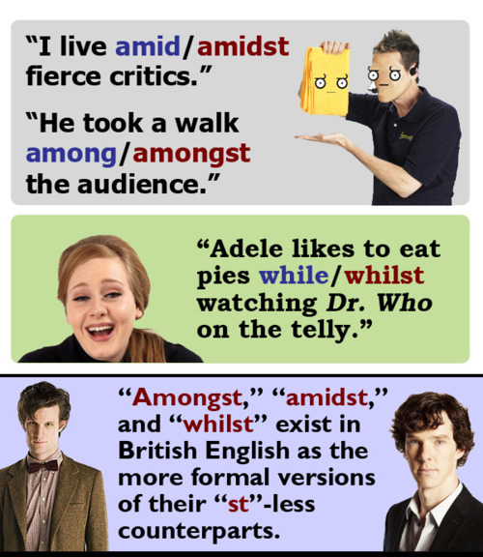He sat amid the trees.  
We camped that night in a shallow valley amid low hills.  
The town sits amid gentle hills and dense forest.  
The actors made their bows amid great applause.

|  |
| --- |
|  |
| **amnesty** |

***a decision by a government that allows political prisoners to go free:***

Most political prisoners were freed under the terms of the amnesty.  
People who hand in illegal weapons will not be prosecuted during the amnesty.  
The government refused to declare an amnesty for people who had not paid the disputed tax.

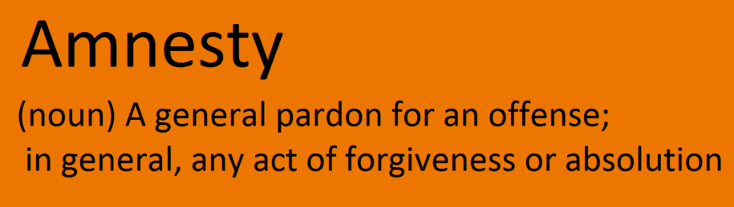



|  |
| --- |
| **among** |

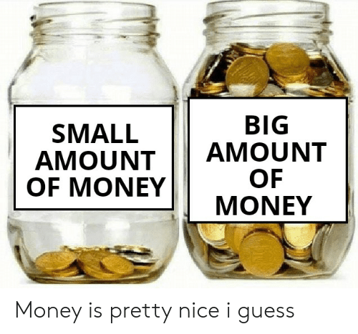Bordeaux is among the world's major wine industry centres.  
The girl quickly disappeared among the crowd.  
I could hear voices coming from somewhere among the bushes.

|  |
| --- |
| **amount** |

They spend equal amounts of time in California and New York.  
Please pay the full amount (=of money) by the end of the month.  
You must pay the full amount in advance.  
They were making a tremendous amount of noise last night.  
She eats an unbelievable amount of food.

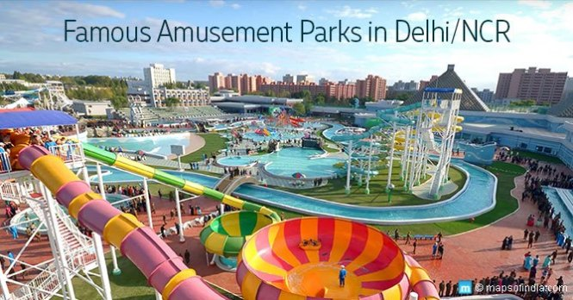

|  |
| --- |
| **amusement park** |

Roller coasters may be the most attractive aspect of an amusement park.  
/ E M Y U Z M I N T /

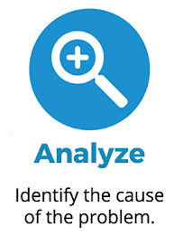

|  |
| --- |
| **analyse: analyze** |

She still needs to analyse the data.  
You need to sit down and analyse why you feel so upset.  
Joe had never tried to analyze their relationship.  
We use a special computer program to analyse all the sales figures.

|  |
| --- |
| **analysis (plr. analyses)** |

Blood samples were sent for analysis.  
You’ll get the results when the analysis is complete.  
Do you agree with Marx’s analysis of the failure of free-market capitalism?

|  |
| --- |
| **ancient** |

People have lived in this valley since ancient times.  
The ancient Britons inhabited these parts of England before the Roman invasion.  
The ancient people of this area worshipped a huge bronze idol in the shape of an elephant.  
Archaeologists study the remains of ancient civilizations.

|  |
| --- |
| **angel - (encıl)** |

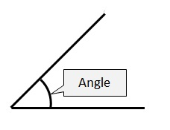The angels in the painting have beatific smiles.

|  |
| --- |
| **angle -(engıl) köşe/açı** |

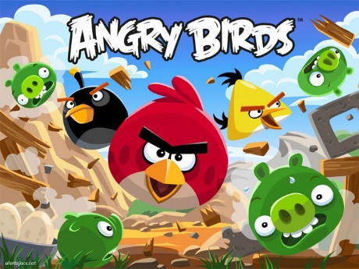The tower is visible from every angle/all angles.

|  |
| --- |
| **angry : mad** |

There is no need to get angry.  
I don't understand what he's angry about.  
I got really angry with her.  
She made me really angry.

|  |
| --- |
| **annoy** |

*to make someone angry:*  
Tina really annoyed me in the meeting this morning.  
I'm sorry - is my cough annoying you?  
It annoys me that she just expects us to help.  
It really annoys me when people expect me to tip as well as pay a service charge in a restaurant.  
I know you’re doing this only to annoy me.

|  |
| --- |
| **annoyed** |

She was annoyed to discover that her husband had taken her car keys.  
I was so annoyed **with** her.

|  |
| --- |
| **annoying** |

It's really annoying when a train is late and there's no explanation.  
He's got a really annoying laugh.  
For me, one of the most annoying things when working on a computer is trying to find the right folder.

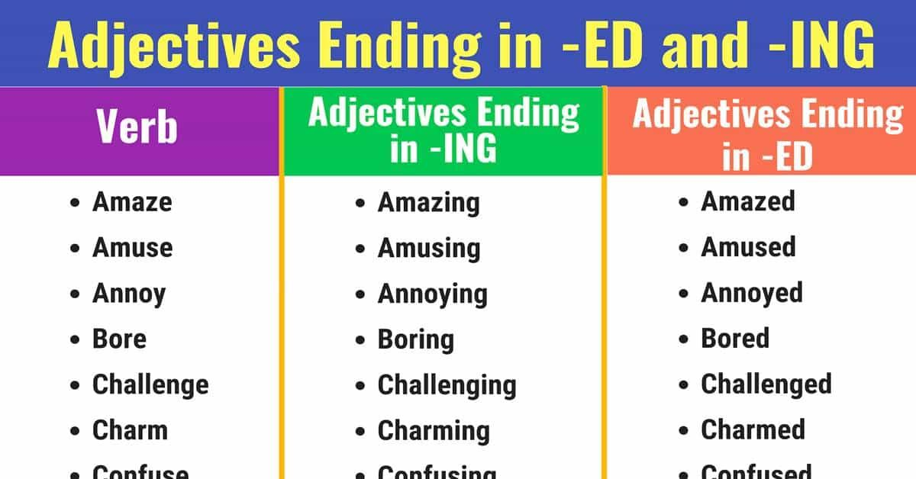

|  |
| --- |
| **annul** |

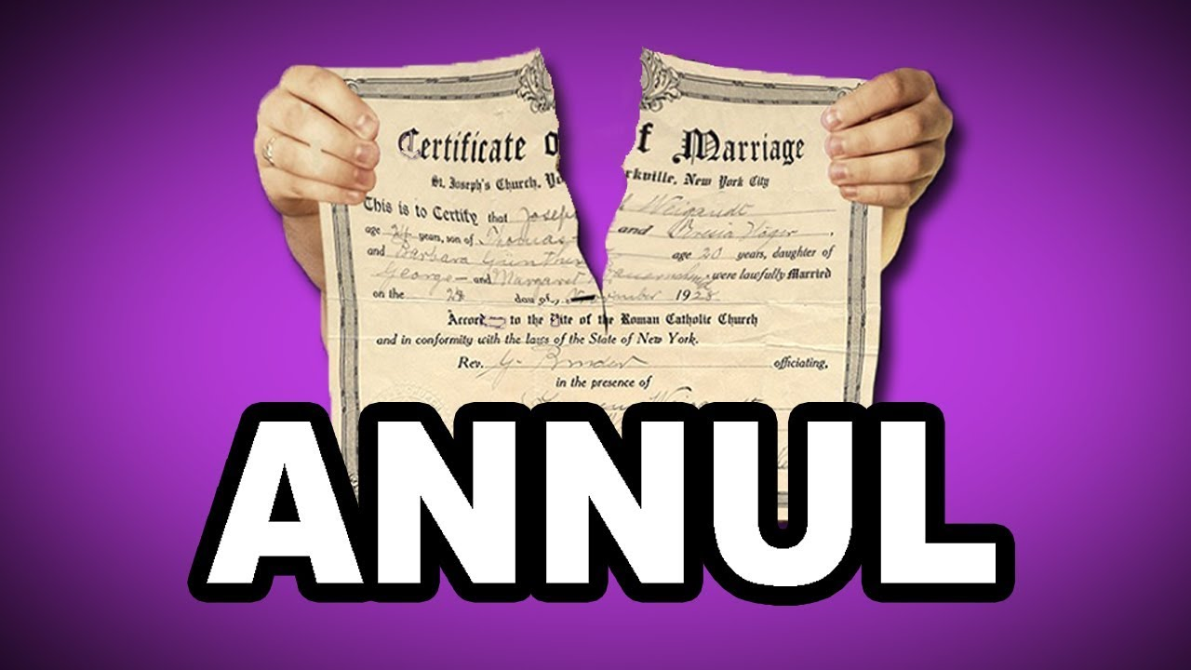*to officially announce that something such as a law, agreement, or marriage no longer exists:*  
His second marriage was annulled because he never divorced his first wife.  
If an election or a contract is annulled, it is declared invalid, so that legally it is considered never to have existed.

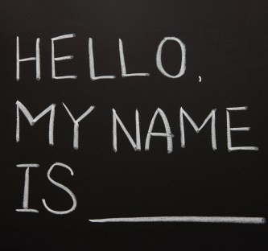

|  |
| --- |
| **anonymous** |

***made or done by someone whose name is not known or not made public:***  
The money was donated by an anonymous benefactor.  
Police said an anonymous caller warned that a bomb was about to go off.  
An attempt to implant an embryo using an egg from an anonymous woman donor was unsuccessful.  
He received an anonymous letter threatening to disclose details of his affair if he didn't pay the money.  
For reasons of personal safety, the informant wishes to remain anonymous.

|  |
| --- |
| **ant** |

We've got ants in our kitchen.  
They studied the behaviour of ants.

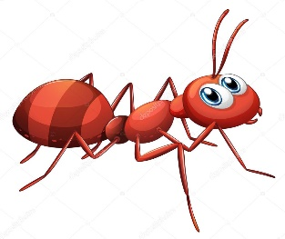

|  |
| --- |
| **antecedent /entisidınt/** |

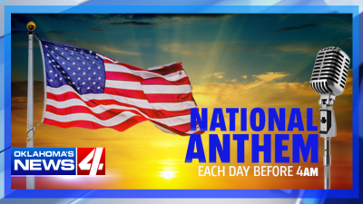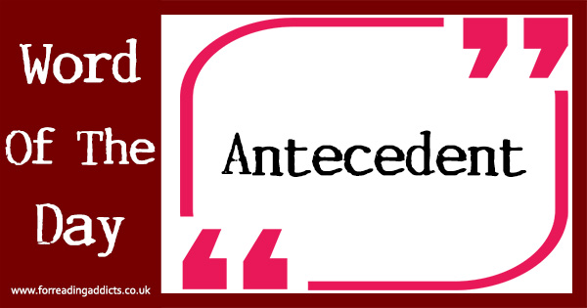***someone or something existing or happening before, especially as the cause or origin of something existing or happening later:***  
Charles Babbage's mechanical calculating engines were the antecedents of the modern computer.  
Many people feel a great curiosity to find out about their antecedents.

|  |
| --- |
| **anthem** |

The national anthems of the teams are played at the beginning of international football matches.  
Mehmet Akif Ersoy was an Ottoman-born Turkish poet, writer, academic, politician, and the author of the Turkish National Anthem.

|  |
| --- |
| **anticipate** |

We don't anticipate any trouble.  
We had one or two difficulties along the way that we didn't anticipate.  
Are you anticipating a lot of people at the party tonight?  
The anticipated inflation figure is lower than last month's.  
It's always best to anticipate a problem before it arises.  
I don’t anticipate (that) we’ll solve all our problems with one meeting.

|  |
| --- |
| **anxious** |

My mother always gets a bit anxious if we don't arrive when we say we will.  
I saw my sister's anxious face at the window.  
It's natural that you should feel anxious when you first leave home.  
I'm anxious (eager) to get home to open my presents.

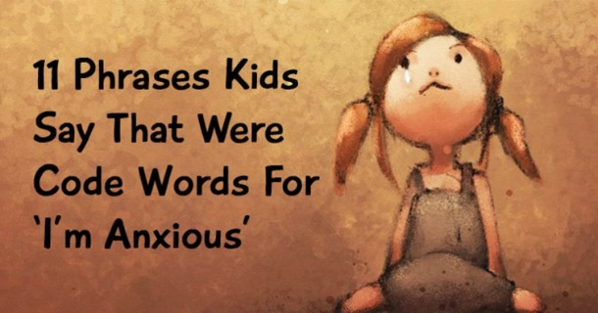

|  |
| --- |
| **anymore : any more** |

She used to love cats but one attacked her and she doesn't like them anymore.  
I don't smoke any more.

|  |
| --- |
| **apologize** |

I must apologize to Isobel for my lateness.  
We apologize for any inconvenience caused.

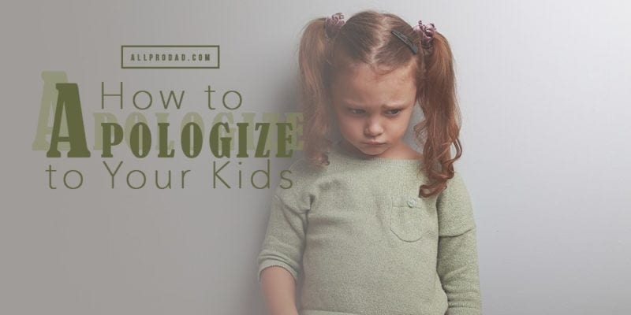

|  |
| --- |
| **apology** |

I owe you an apology - I'm afraid I forgot to send Amanda that report.  
I have an apology to make to you - I'm afraid I opened your letter by mistake.  
I offered her an apology, but she wouldn't accept it.  
He sent me some flowers by way of an apology.

|  |
| --- |
| **apparently** |

Apparently the company is losing a lot of money.  
I wasn’t there, but apparently it went well.  
Apparently, Jim's a really good tennis player.  
Apparently it's going to rain today.  
His resignation was apparently for personal rather than professional reasons.

|  |
| --- |
| **appeal** |

*a request made to a court of law or to someone in authority to change a previous decision:*  
The case went to the court of appeal/the appeal court.  
He won his appeal and the sentence was halved.  
She has lodged (= made) an appeal against the severity of the fine.

*to make a serious or formal request, especially to the public, for money, information, or help:*  
They're appealing for clothes and blankets to send to the devastated region.  
The police are appealing to the public for any information about the missing girl.  
I tried to appeal to (= ask for support based on) his sense of loyalty, stressing how good the company had been to him.  
Church leaders have appealed to the government to halt the war.

*to interest or attract someone:*  
Our partner company has local knowledge and will know which products appeal.  
The new phone is designed to appeal to consumers who find normal phone tariffs confusing.  
**It doesn't appeal to me**.  
bana hitap etmiyor

|  |
| --- |
| **appear : show up** |

Things aren't always what they appear (seem) to be.  
He suddenly appeared in the doorway.  
Two weeks after we'd planted the seeds, little green shoots started to appear.  
His colleagues became suspicious when he did not appear at work since he was always punctual.

|  |
| --- |
| **apple** |

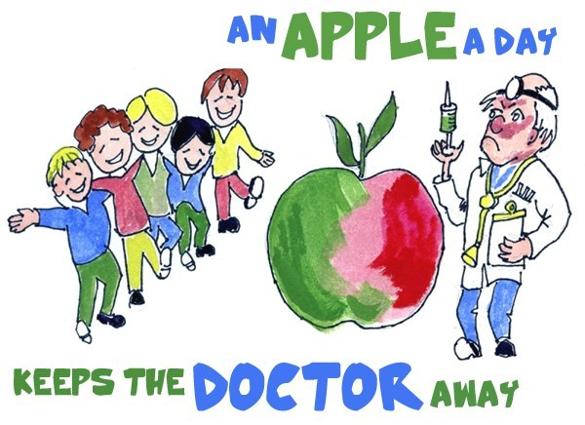An apple a day keeps the doctor away.  
One bad or rotten apple spoils the whole barrel.

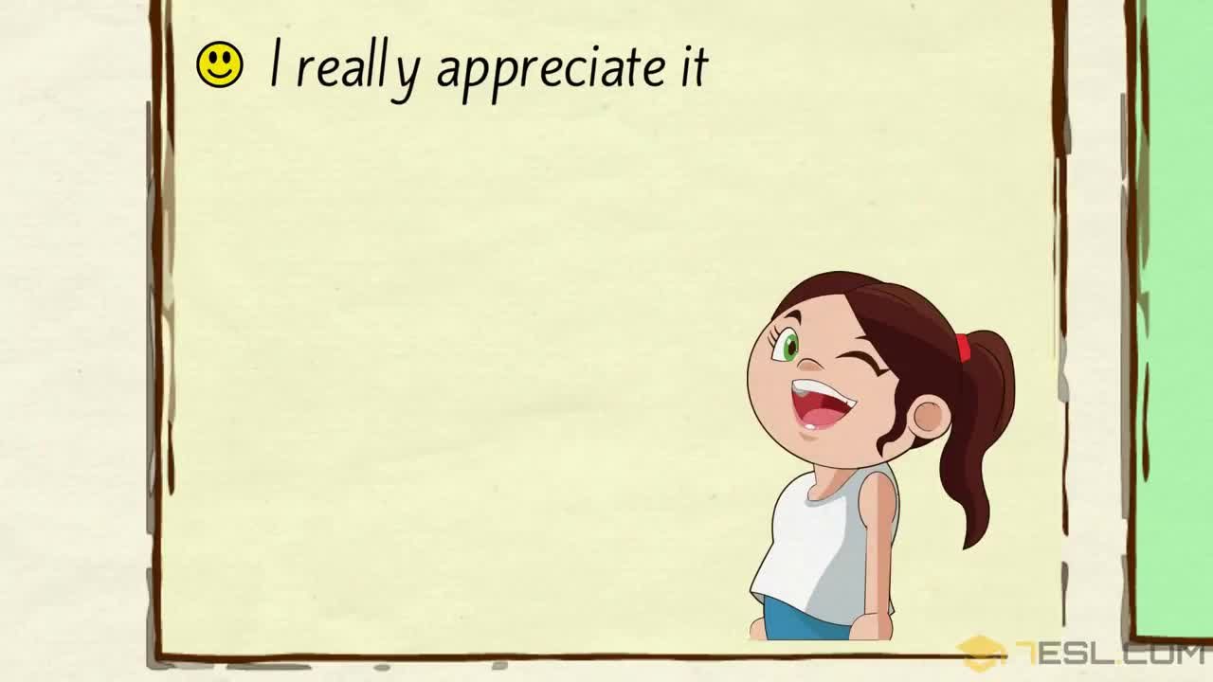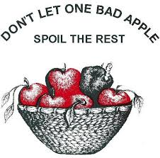

|  |
| --- |
| **appreciate** |

I don't think you appreciate how much time I spent preparing this meal.  
I appreciate your making the effort to come.  
I would appreciate it if you could let me know (= please let me know) in advance whether or not you will be coming.

|  |
| --- |
| **approach** |

If you look out of the window on the left of the bus, you'll see that we're now approaching the Tower of London.  
Since our research so far has not produced any answers to this problem, we need to adopt a different approach to it.  
I've just read an interesting book which has a new approach to Shakespeare.  
I'm not sure how to approach the problem.

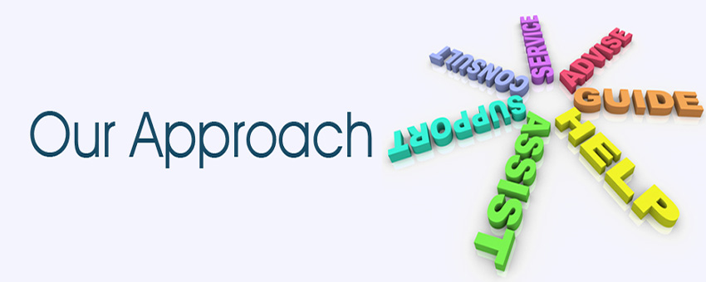

|  |
| --- |
| **approval** |

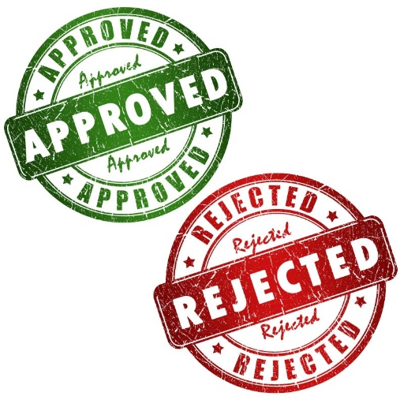The project has now received approval from the government.  
The president has already given his approval to the plan.  
It is just three months since we received official approval to go ahead with the project.

|  |
| --- |
| **approve** |

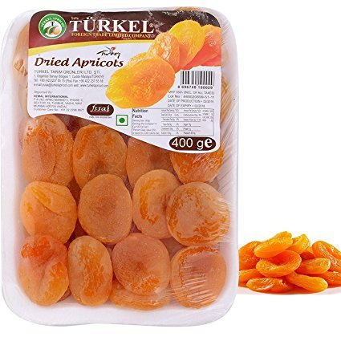He doesn't approve of smoking.  
I thoroughly approve of what the government is doing.

|  |
| --- |
| **apricot** |

Prunes, grapes, and apricots were some of the major crops.

|  |
| --- |
| **architect** |

He is probably the best known living architect.  
Doug and Wendy worked with an architect to create their dream home.  
We're working with a team of architects on the plans for the new building.

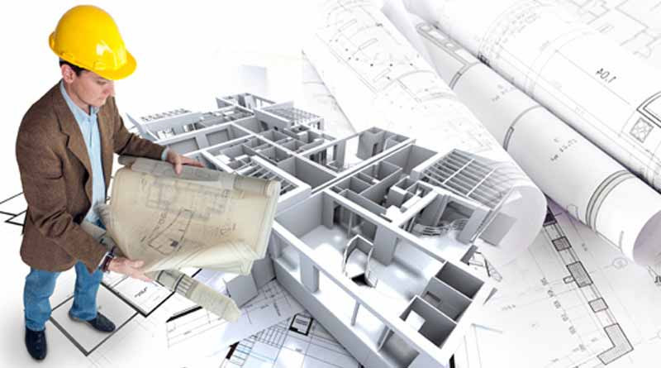

|  |
| --- |
| **architecture** |

Modernist architecture tries to conquer nature instead of working with it.  
He earned a master's degree in architecture.  
He studied architecture at university.   
City Hall is a fine example of Gothic architecture.  
We spent most of our time in Barcelona just looking at the architecture.

|  |
| --- |
| **area** |

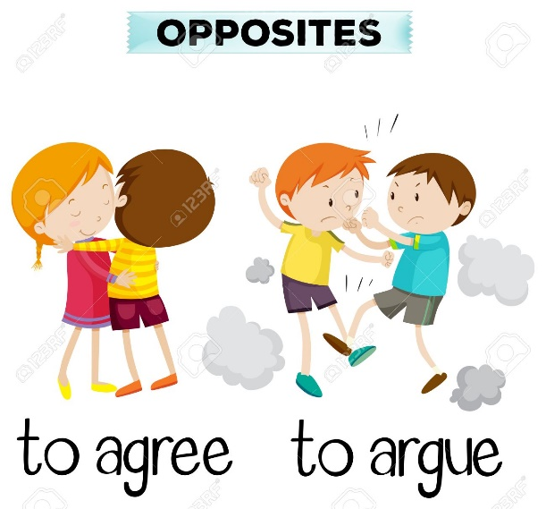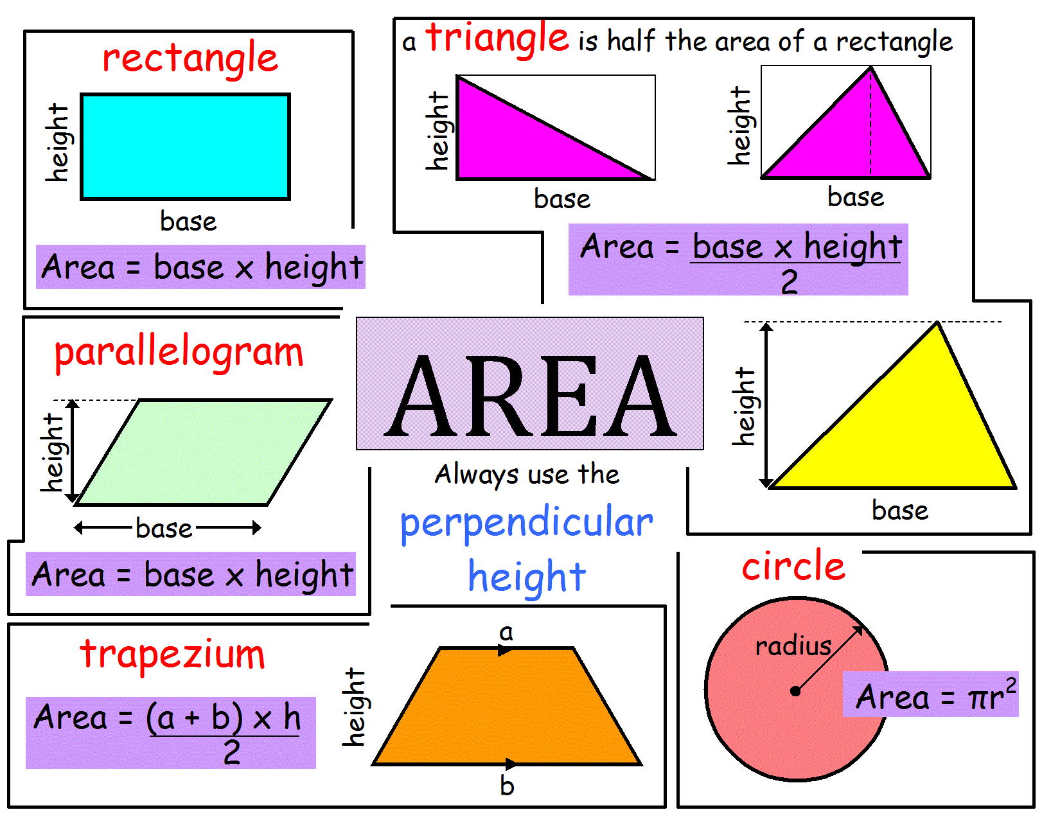This area of the park has been specially designated for children.  
Software is not really my area of expertise.  
Crime rates are much higher in urban areas.  
Many areas of Africa have suffered severe drought this year.  
The course covers three main subject areas.  
There’s a nice play area for the kiddies.

|  |
| --- |
| **argue: discuss: debate** |

There is no use in arguing any more.  
The children are always arguing.  
They were arguing over/about which film to go and see.

|  |
| --- |
| **arm** |

He had a tattoo on his left arm.  
Tim’s mother put her arms around him.  
Pat was carrying a box under his arm.  
They walked along the beach arm in arm (=with their arms bent around each other’s).  
She broke her left arm in a riding accident.  
He was taken to hospital with a broken arm.



|  |
| --- |
| **armchair** |
| She sat in an armchair by the fire, reading a newspaper. She imagined herself sitting in her favourite armchair back home. |

|  |
| --- |
| **armistice** |

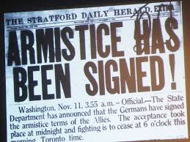A two-week armistice has been declared between the rival factions.  
Since the 1953 armistice, the two sides have never signed a peace treaty.

|  |
| --- |
| **army** |

When did you join the army?  
He has decided on a career in the British Army.

|  |
| --- |
| **arrest** |

He was arrested when customs officers found drugs in his bag.  
The police arrested her for drinking and driving.

|  |
| --- |
| **arrival** |

Hundreds gathered to await the boxer's arrival at the airport.  
On arrival at the police station, they were taken to an interview room.  
We regret the late arrival of Flight 237.

|  |
| --- |
| **arrive** |

What time will your train arrive?  
It was dark by the time we arrived at the station.  
We arrived in Prague later that day.  
We didn't arrive at our hotel until after midnight.  
An excited crowd waited for the singer to arrive.

|  |
| --- |
| **arrogant** |

I found him arrogant and rude.  
I watched the interview and thought he seemed quite arrogant.  
I never met a more conceited and arrogant young man.  
He has a self-confidence that is sometimes seen as arrogance.  
The authorities had behaved arrogantly, she said.

|  |
| --- |
| **art** |

Art and English were my best subjects at school.  
The gallery has an excellent collection of modern art.  
Drama is an art that is traditionally performed in a theatre.  
Do you regard film as entertainment or as an art?

|  |
| --- |
| **artificial** |

***made by people, often as a copy of something natural:***

clothes made of artificial fibres  
an artificial heart  
an artificial lake

|  |
| --- |
| **artificial intelligence** |

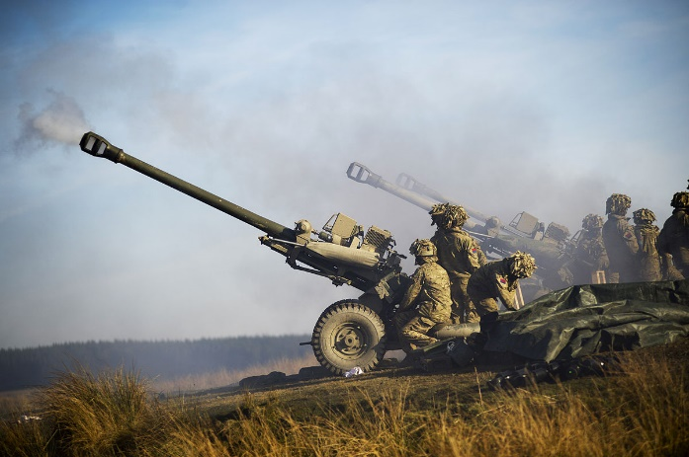*Artificial intelligence (AI) is an area of computer science that emphasizes the creation of intelligent machines that work and react like humans.*

|  |
| --- |
| **artillery** |

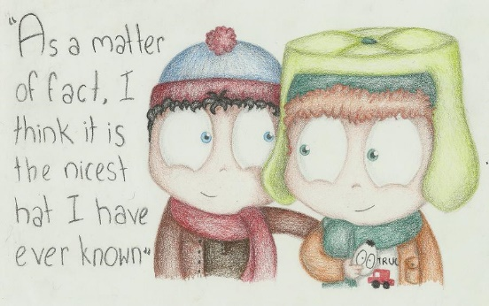Naval gunfire and ground-based artillery are generally less accurate than many aircraft-borne weapons.  
He served as an artillery officer.

|  |
| --- |
| **as a matter of fact** |

***used when adding more details about what you have just said***  
‘Have you had many visitors yet?’ ‘No, as a matter of fact you’re the first.’  
I knew him when we were in college – as a matter of fact we were on the same course.  
I like almost all women, as a matter of fact.

|  |
| --- |
| **as if/as though** |

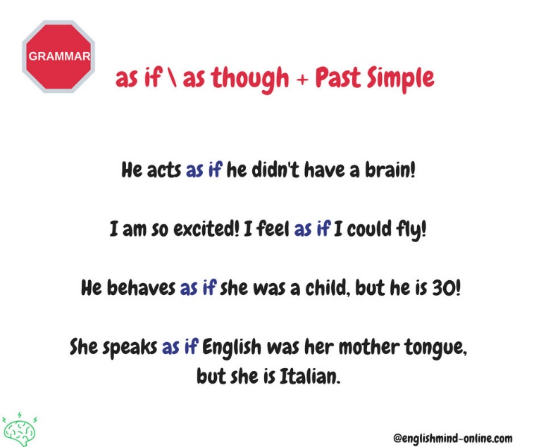She looked as if she was about to cry.  
She acted as though she had never seen me before, when I'd just met her at lunch.

|  |
| --- |
| **as long as** |

I'll remember you as long as I live.  
You can come as long as you're quiet.  
I'll help as long as you buy pizza!  
As long as I'm here, I'll help.

|  |
| --- |
| **as well** |

Our vacation was a disaster: not only was the food terrible, the weather was awful as well.  
While you're at the store, could you get a few things for me as well?

|  |
| --- |
| **as well as** |

We have a responsibility to our community as well as to our families.

|  |
| --- |
| **ash** |

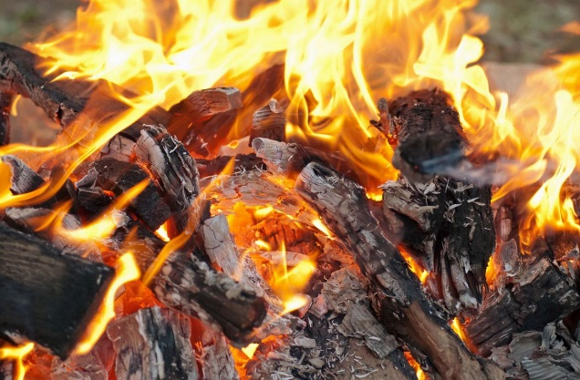Her ashes were scattered at sea.  
We cleaned the ashes out of the fireplace.  
The house burnt to ashes.  
*cigarette ash*  
*volcanic ash*

|  |
| --- |
| **ashamed of: shy: timid** |

You've got nothing to be ashamed of.  
How could you treat her like that? I'm so ashamed of you.!

|  |
| --- |
| **ashtray** |

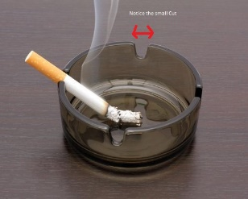***a small dish or container, sometimes decorative, in which people can leave cigarette ash and cigarette butts***

|  |
| --- |
| She came up with a routine for visiting the tables, and even managed to empty a few ashtrays. |
| **ask** |

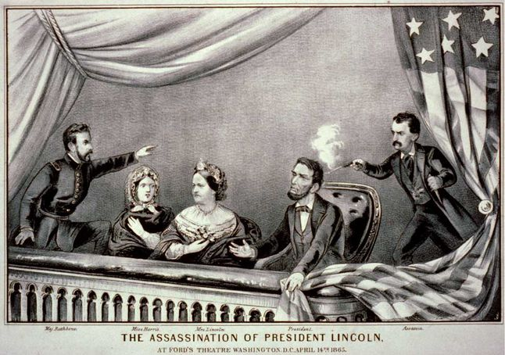Can I ask one thing? Can I ask you something?  
If you need any help, please don't hesitate to ask.  
She asked her manager if/whether she could leave early to pick up the kids.  
I asked to see my accountant.

|  |
| --- |
| **assassinate** |

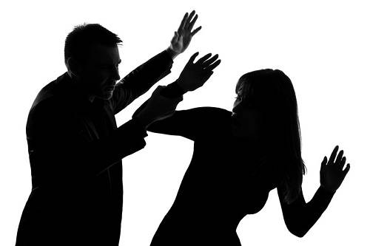President Kennedy was assassinated in Dallas, Texas, in 1963.  
a plot to assassinate the president

|  |
| --- |
| **assault** |

***a violent attack:***  
He was charged with sexual assault.  
The number of indecent assaults has increased alarmingly over the past year.  
an assault on a police officer  
They launched an assault on the capital yesterday.  
Oregon, Washington and California are all under assault from a wildfire season of historic proportions, with the firefighting effort compounded by the coronavirus pandemic and misinformation online.

***a determined or serious attempt to do something difficult:***  
Women's groups have demanded a nationwide assault on sexism in the workplace.  
She died heroically during an assault on the world's second-highest mountain.

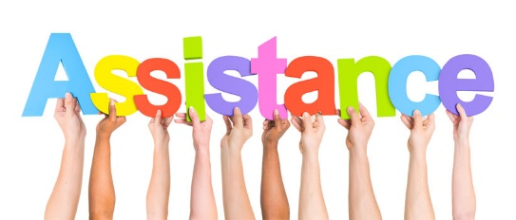***to attack someone violently:***  
A woman and a man have been convicted of assaulting a police officer.  
He had attempted to sexually assault the woman.

|  |
| --- |
| **assist : help** |

You will be expected to assist the editor with the selection of illustrations for the book.  
Yasmin assisted in the preparation of this article.

|  |
| --- |
| **assistance** |

The company needs more financial assistance from the government.  
A £1 billion investment would be of considerable assistance to the local economy.  
Can I be of any assistance (= can I help), madam?  
Teachers can't give pupils any assistance in exams.

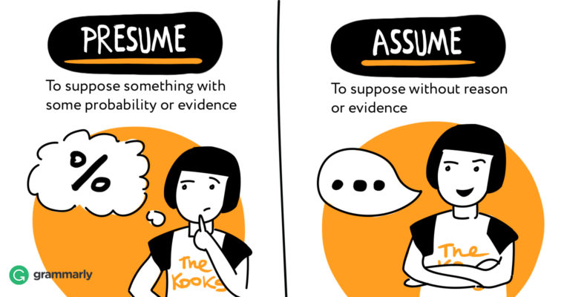

|  |
| --- |
| **assume - presume** |

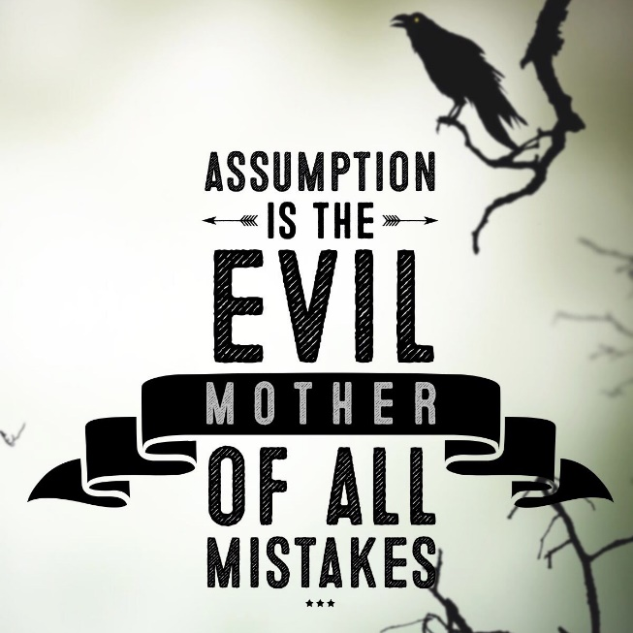I assumed that you knew each other because you went to the same school.  
Let's assume that it is true.

|  |
| --- |
| **assumption** |

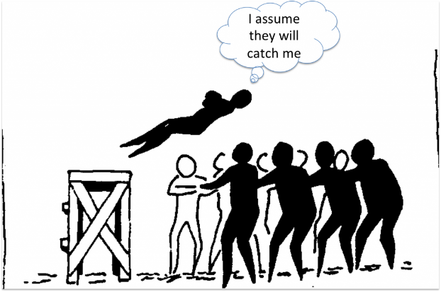***something that you accept as true without question or proof:***  
These calculations are based on the assumption that prices will continue to rise.  
We tend to make assumptions about our staff's ability based on very little evidence.  
A lot of people make the assumption that poverty only exists in the Third World.  
You’re making a lot of assumptions for which you have no proof.

|  |
| --- |
| **astonish** |

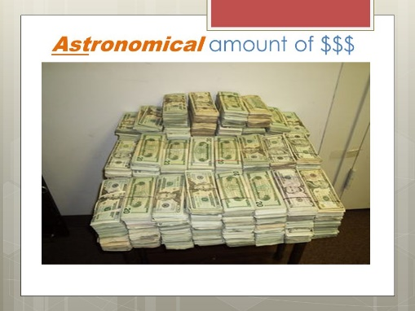Her reply astonished me.  
What astonishes me most is his complete lack of fear.  
Einstein's work still astonishes physicists.

|  |
| --- |
| **astronomical** |

an astronomical amount is extremely large:  
astronomical prices, costs, etc are extremely

|  |
| --- |
| **astute  /estut/** |

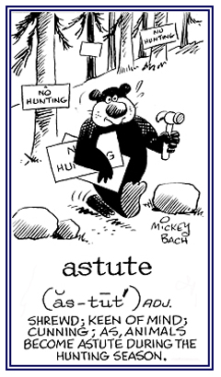***able to understand situations or behaviour very well and very quickly, especially so that you can get an advantage for yourself***  
The President's wife is often politically astute, ambitious and very influential in White House policy decisions.  
Morgan was surprised at how astute she was. "How did you know that?" he asked.

|  |
| --- |
| **at** |

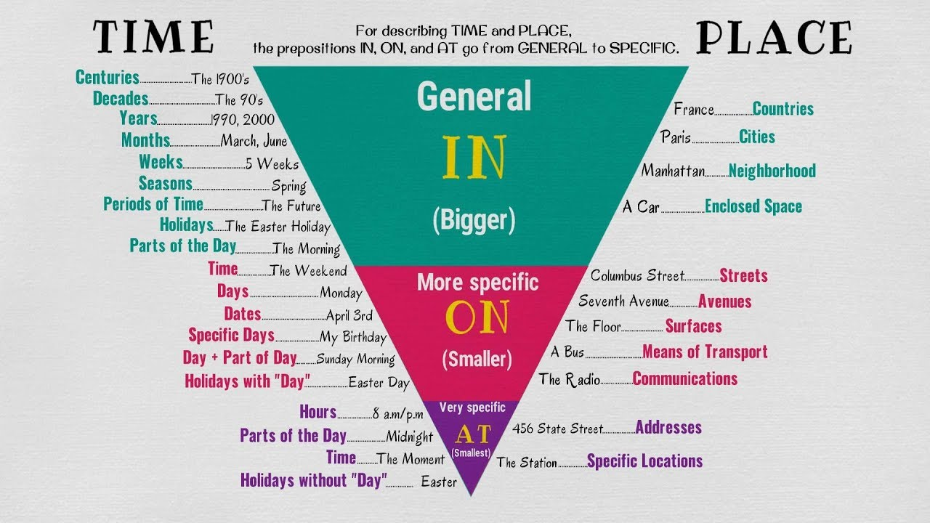We'll meet you at the entrance.  
Turn left at the traffic lights, and you'll see the hospital straight ahead.  
There's a meeting at 2.30 this afternoon.

She smiled at me.  
We were surprised at the news.  
I was never very good at sports.

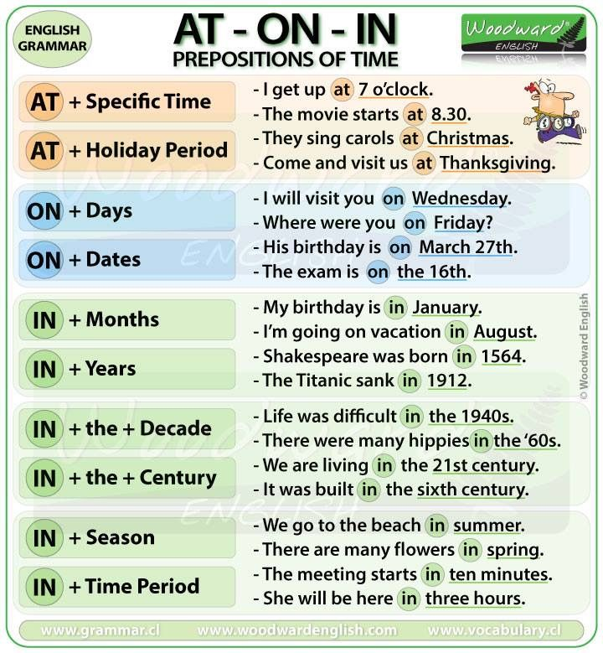

|  |
| --- |
| **atmosphere** |

There's a very relaxed atmosphere in our office.  
These factories are releasing toxic gases into the atmosphere.  
The atmosphere in the room was so stuffy I could hardly breathe.

|  |
| --- |
| **attempt** |

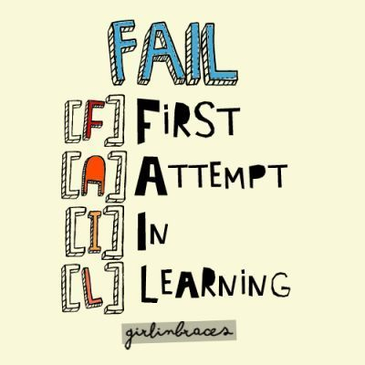My second attempt at making pastry was a bit more successful.  
There's no point in even attempting an explanation - he'll never listen.  
This is my second attempt at the exam.  
The pilot made several attempts to regain control of the aircraft.

|  |
| --- |
| **attend : join** |

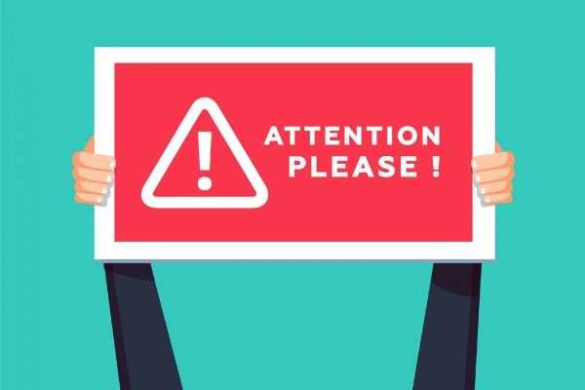I attended NATO Network Control Sytems (NNCS) Course in Latina in 1999, INFOSEC Officer Course in 2007.  
Over two hundred people attended the funeral.  
The meeting is on the fifth and we're hoping everyone will attend.

|  |
| --- |
| **attention** |

Could I have your attention, please?  
Could I draw your attention to item number three on the agenda?  
Wait a moment and I'll give you my full/undivided attention.

|  |
| --- |
| **attic** |

I've got boxes of old clothes in the attic.

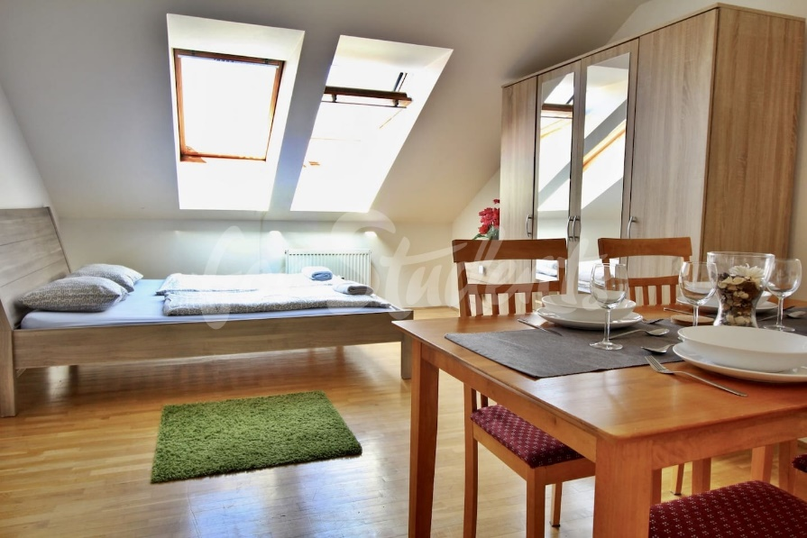

|  |
| --- |
| **attractive** |

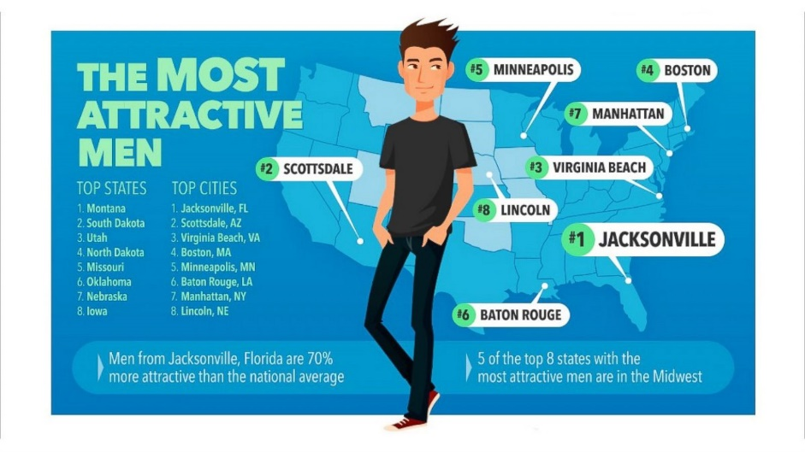He was a very attractive young man.  
I find her very attractive.

|  |
| --- |
| **aunt** |

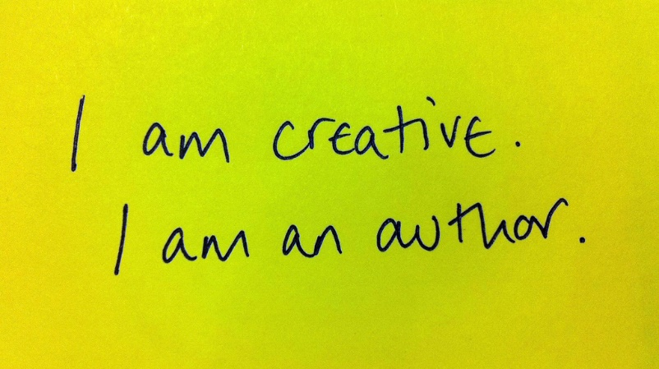She visits her aunt twice a month.  
Jerome has an aunt and uncle in Laguna Hills and some relatives in South Dakota.  
We're going to visit my aunt and uncle on Sunday

|  |
| --- |
| **author** |

He was the author of two books on Turkey.  
She is also a prolific author with more than 70 books published.  
The author has tried to deal with a very difficult subject.  
In his preface, the author says that he took eight years to write the book.



|  |
| --- |
| **autumn: fall** |

We like to travel in (the) autumn when there are fewer tourists.  
Last autumn we went to Germany.  
It was early autumn and the leaves were turning yellow.



|  |
| --- |
| **available** |

There's no money available for an office party this year.  
I'm afraid I'm not available right now.

|  |
| --- |
| **average** |

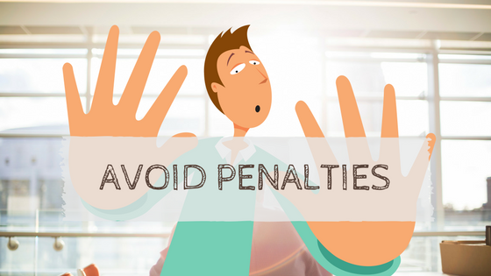The age of the candidates ranged from 29 to 49 with an average age of 37.  
The average cost of making a movie has risen by 15%.  
Last winter was colder than average.  
My income's rather variable, but I earn £175 a day on average.

|  |
| --- |
| **avoid** |

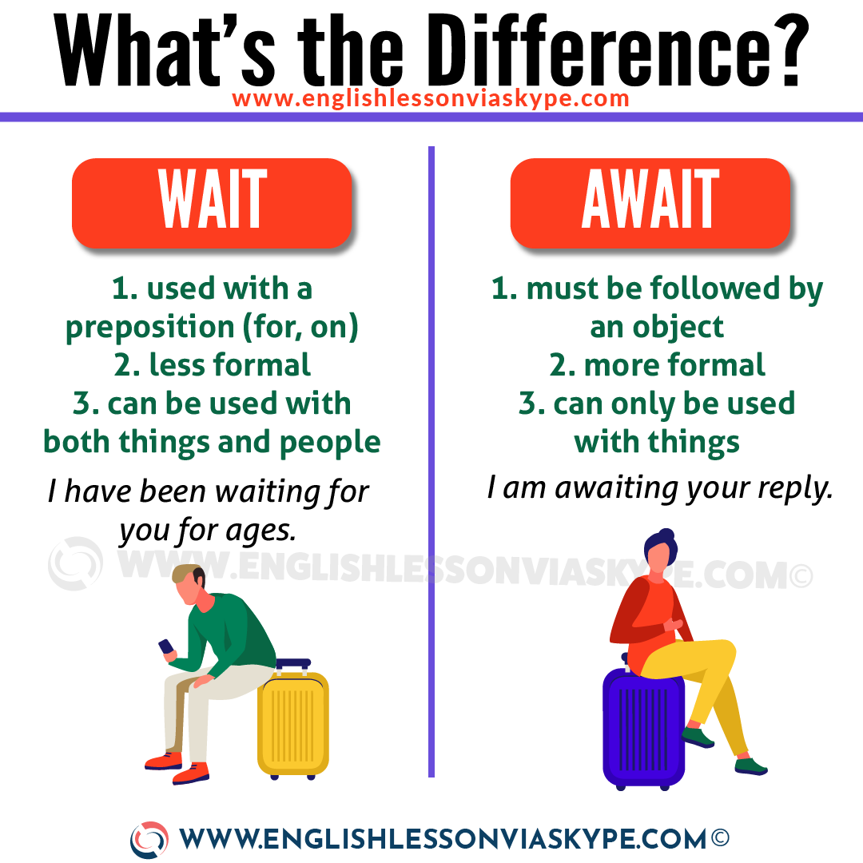I try to avoid supermarkets on Saturdays - they're always so busy.  
I'm anxious to avoid the motorway at rush hour.

Do you think Lukas is avoiding me? I haven't seen him all day.  
Try to avoid foods that contain a lot of fat.  
If you want to lose weight, avoid eating between meals.  
Understanding differing viewpoints is a good start toward avoiding conflict in the workplace.

|  |
| --- |
| **await : wiat** |

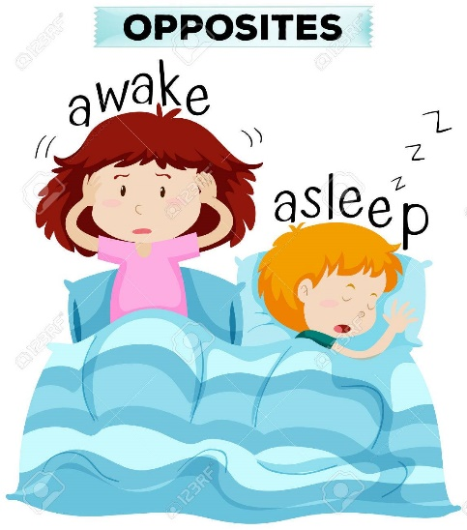He's anxiously awaiting his test results.  
The two men are awaiting trial, scheduled to begin next month.  
The committee is awaiting a decision from head office before it takes any action.

|  |
| --- |
| **awake** |

"Is Oliver awake yet?" "Yes, he's wide (= completely) awake and running around his bedroom."  
I find it so difficult to stay awake during history lessons.  
I drink a lot of coffee to keep me awake.  
She used to lie awake at night worrying about how to pay the bills.

|  |
| --- |
| **awaken** |
| ***to stop sleeping or to make someone stop sleeping:***  They were awakened by the sound of gunfire. I awakened at dawn to find him beside me. |
| **aware** |

I wasn't even aware that he was ill.  
Has Claude paid the phone bill? Not as far as I'm aware.

|  |
| --- |
| **awesome** |

You look totally awesome in that dress.

|  |
| --- |
| **awful** |

The food was awful.  
The weather is awful today.

|  |
| --- |
|  |